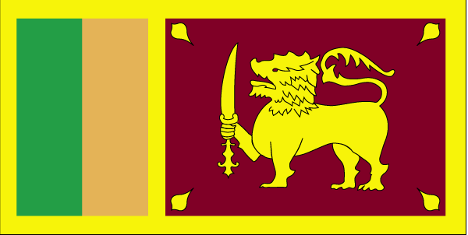 | 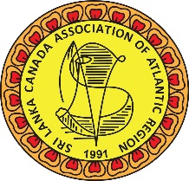
Sri Lanka Canada Association of Atlantic Region
www.slcaar.ca

APPLICATION FOR SINGLE/FAMILY MEMBERSHIP

SURNAME: ______________________
NAME OF APPLICANT: ______________________ BIRTH DATE: __________
NAME OF SPOUSE: ______________________ BIRTH DATE: __________

NAME(S) OF DEPENDENT CHILDREN:
NAME BIRTH DATE
______________________________ _______________
______________________________ _______________
______________________________ _______________
______________________________ _______________

ADDRESS: TELEPHONE NO:
_________________________
_________________________ Res: ___________ WORK: _____________
_________________________ Fax: ___________
_________________________ EMAIL: _____________________________

Membership in the Association is open to all residents of Nova Scotia, who are of Sri Lankan origin, their spouses and children; or who hold the same objectives of the Association and are actively committed to achieving these Objectives, as determined by the Executive Committee and subject to ratification at the next General Meeting. Members are expected to contribute and participate by undertaking tasks assigned by the Executive Committee to achieve the Objectives of the Association.

I agree to be bound by the By-Laws of the Sri Lanka Canada Association of the Atlantic Region and to uphold the Objectives of the Association.

SIGNATURE: ______________________ DATE: ________________

FOR EXECUTIVE COMMITTEE USE:

PROPOSED BY: ______________________ SECONDED BY: ________________________

APPROVED: ______________________ DATE: ________________________

COMMENTS: ___________________________________________________________________

